**Dr. J. J. Magdum Trust’s**

**Dr. J. J. Magdum College of Engineering,**

**Jaysingpur. 416101**

**Department of Information Technology**

**“ENVIRONMENTAL PROJECT REPORT”**

**“A Study of**

**Conservation of natural Resources”**

**Submitted by,**

**1. HULWAN SHANTANU JAYDEEP**

**2. INGOLE RAVIRAJ NAMDEO**

**3. KALEL AVISHKAR BHARAT**

**4. DUDHAL VIJAY SUNIL**

**5.**

**Date: - / /2023 Project Guide**

**Place- JAYSINGPUR Prof. Chougule P. A.**

**Year of Submission**

**2022-23Dr. J. J. Magdum Trust’s**

**Dr. J. J. Magdum College of Engineering,**

**Jaysingpur. 416101**

**Department of Information Technology**

**CERTIFICATE**

This is to certify that the project report titled “**A study of Conservation of Natural Resources”**

Submitted by,

**1. HULWAN SHANTANU JAYDEEP**

**2. KALEL AVISHKAR BHARAT**

**3. INGOLE RAVIRAJ NAMDEO**

**4. DUDHAL VIJAY SUNIL**

**5.**

In Practical fulfillment of the subject “**Environmental studies**” UGC (university grand commission) compulsory course has been completed under the guidance of Prof. Chougule P.A. The conclusion drawn are based on the data collected by them during their stipulated period of field work to the best of our knowledge and belief the matter included in it is their original work

Project In charge Head of Department Principal

Date:

Place: College seal

**Dr. J. J. Magdum Trust’s**

**Dr. J. J. Magdum College of Engineering,**

**Jaysingpur. 416101**

**DECLARATION**

We the undersigned Students of **S.E. (IT)** declare that the field work report entitled “**A study of Conservation of Natural Resource**” written and submitted under the guidance of **Prof. Chougule P.A.** is our original work. The empirical finding is this report is based on the data collected by us. The matter assimilated in this report is not reproduction from any readymade report.

Date :- / /2023

Place-Jaysingpur.

|  |  |  |  |
| --- | --- | --- | --- |
| **Sr No.** | **Name of students** | **Roll No** | **Sign.** |
| 1 | **HULWAN SHANTANU JAYDEEP** | 21 |  |
| 2 | **DUDHAL VIJAY SUNIL** | 13 |  |
| 3 | **INGOLE RAVIRAJ NAMDEO** | 23 |  |
| 4 | **KALEL AVISHKAR BHARAT** | 28 |  |

**Department of Information Technology**

**INDEX**

|  |  |  |
| --- | --- | --- |
| **Sr.No.** | **Contents** | **Page No.** |
| **01** | **Introduction of Environment, Importance Public Awareness &**  **Various types of Environmental Pollution** |  |
| **02** | **Introduction of Project Report** |  |
| **03** | **Aim and Objectives of Project Report** |  |
| **04** | **Actual Methodology** |  |
| **05** | **Observations** |  |
| **06** | **Summary & Conclusion** |  |
| **07** | **Bibliography** |  |

**Introduction of Environment, Importance, Public Awareness.**

**AND**

**Various types of Environmental Pollution.**

Introduction of Environment: -

The Environment is our basic life support system and is composed of living beings, physical surroundings, and climatic conditions. It is derived from a French word, “Environner”, which means “to surround”. The term environment includes all biotic and abiotic entities around us. Biotic refers to the world of living organisms, whereas Abiotic refers to the world of non-living elements.

Environmental studies focus on the impact of human activities on the environment and the need for sustainable practices to ensure the long-term health and well-being of the planet. This includes the study of environmental problems such as pollution, climate change, habitat destruction, and resource depletion.

The field of environmental studies is important for developing solutions to these problems and promoting sustainable development practices. It involves collaboration between scientists, policymakers, and stakeholders to identify problems, develop solutions, and implement strategies for a more sustainable future.

Importance of Environment: -

The Environment provides us with the essential elements – air, water, food, and land which are essential for life to flourish on the Earth. Environment not only works to maintain balance in the climate and also provides all the things necessary for life.

The environment is of vital importance to all living beings on Earth. Here are some reasons why the environment is important:

1. Life Support System:

The environment provides essential resources such as air, water, food, and shelter that are necessary for the survival of all living beings.

1. Biodiversity:

The environment is home to a vast array of plant and animal species, which contribute to the natural balance of ecosystems and support human life through services such as pollination, pest control, and nutrient cycling.

1. Climate Regulation:

The environment plays a critical role in regulating the Earth's climate by absorbing and releasing heat, and regulating the carbon cycle.

1. Cultural Significance:

The environment holds cultural, spiritual, and historical significance for many societies and indigenous communities, and is often the basis of their identity and way of life.

1. Economic Value:

The environment provides numerous economic benefits such as natural resources, tourism, and recreation, which contribute to the livelihoods of millions of people around the world.

Public Awareness: -

Public awareness is the public's level of understanding about the importance and implications of a certain program or an activity. Raising public awareness is not the same as telling the public what to do. It is explaining issues and disseminating knowledge to people so that they can make their own decisions.



It is important to raise public awareness on the environment because it helps people to understand the impact of human activities on the natural world, and to appreciate the value of conserving natural resources and protecting the planet. When people are aware of environmental issues, they are more likely to take action to protect the environment, such as reducing their carbon footprint, conserving water, and supporting environmentally-friendly policies and practices.

Various types of Environmental Pollution:

Environmental pollution refers to the introduction of harmful substances or contaminants into the natural environment, which can cause adverse effects on living organisms and the natural world. Modifying the environment caused by human influence, which often renders the environment harmful and unpleasant to live in, is called Pollution. Atmospheric Pollution is caused by gases such as Sulphur dioxide, carbon monoxide, and nitrogen oxides being released into the atmosphere by various industries and by burning fossil fuels. Water Pollution is caused by many substances, such as those found in fertilizers and industrial effluents. There are several types of environmental pollution, including:

**Air Pollution**:

This refers to the release of harmful chemicals and particulate matter into the air, which can lead to respiratory problems, cardiovascular disease, and other health issues. It is the result of a wide range of natural sources and human activities such as the greenhouse gas emissions caused by burning fossil fuels like coal and petroleum, construction and demolition, and the use of chemical and synthetic products. Wildfires are also a major source of air pollution.

**Cause: -**

Air pollution is caused by solid and liquid particles and certain gases that are suspended in the air. These particles and gases can come from car and truck exhaust, factories, dust, pollen, 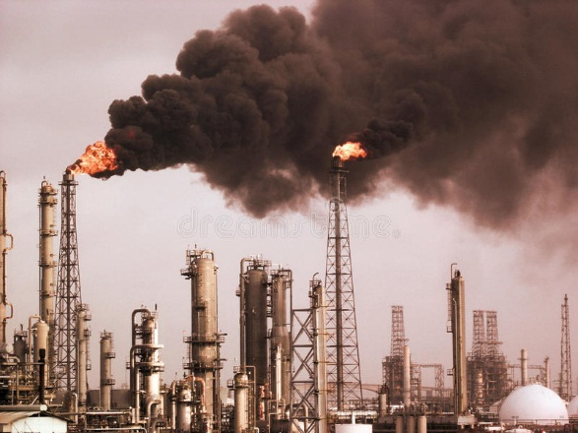mold spores, volcanoes and wildfires. The solid and liquid particles suspended in our air are called aerosols. Air pollution happens when solid and liquid particles—called aerosols—and certain gases end up in our air. These particles and gases can be bad for the planet and for our health, so keeping track of them is important. Air pollution can also happen indoors – for instance; radon gas is colorless and odourless. It also has the tendency to accumulate inside closed spaces, such as the basements of buildings. This gas is also considered to be a carcinogen; hence it may cause cancer.

**Effect: -**

People experience a wide range of health effects from being exposed to air pollution. Effects can be broken down into short-term effects and long-term effects. Like people, animals, and plants, entire ecosystems can suffer effects from air pollution. Haze, like smog, is a visible type of air pollution that obscures shapes and colors. Hazy air pollution can even muffle sounds. Air pollution particles eventually fall back to Earth. Air pollution can directly contaminate the surface of bodies of water and soil. This can kill crops or reduce their yield. It can kill young trees and other plants.

**Solution: -**

Actions You Can Take to Reduce Air Pollution: -Follow these Tips Every Day to Reduce Pollution: Conserve energy - at home, at work, everywhere. Look for the ENERGY STAR label when buying home or office equipment. Carpool, use public transportation, bike, or walk whenever possible. Follow gasoline refueling instructions for efficient vapor recovery, being careful not to spill fuel and always tightening your gas cap securely. Consider purchasing portable gasoline containers labeled “spill-proof,” where available. Keep car, boat, and other engines properly tuned. Be sure your tires are properly inflated. Use environmentally safe paints and cleaning products whenever possible. Mulch or compost leaves and yard waste. Consider using gas logs instead of wood.

**Water Pollution**:

This refers to the contamination of water bodies such as rivers, lakes, and oceans, due to the release of chemicals, sewage, and other pollutants. Water pollution can harm aquatic life, and also affect human health when contaminate water is consumed or used for daily activities.

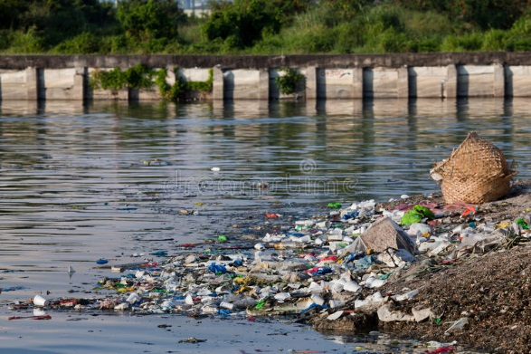

**Causes:** -

Causes of water pollution can be anything from overdevelopment to inappropriate sewage disposal. Once the cause of water pollution is identified, solutions can be made to combat the issue. Some of the water pollution causes - Urban development, Sewage & wastewater, Mining, Marine dumping, Oil leakages, Burning fossil fuels, Agriculture: Chemical fertilizers & pesticides, Sewer leakages, Global warming, Radioactive waste, Animal waste, Eutrophication, Acid rain

**Effects: -**

Deteriorating water quality is damaging the environment, health conditions and the global economy. The president of the World Bank, David Maples, warns of the economic impact: "Deteriorating water quality is stalling economic growth and exacerbating poverty in many countries". The explanation is that, when biological oxygen demand — the indicator that measures the organic pollution found in water — exceeds a certain threshold, the growth in the Gross Domestic Product (GDP) of the regions within the associated water basins falls by a third. In addition, here are some of the other consequences: Destruction of biodiversity, Contamination of the food chain, Lack of potable water, Disease, etc.

**Solution: -**

There is no single or simple answer to stop the water pollution crisis, however, there are many solutions to prevent water pollution both in our daily lives and within industries. We can separate the issue with water pollution into 10 notable solutions: Wastewater Treatment, Reducing Plastic Waste, Water Conservation, Water-efficient Toilets, Septic Tanks, Do Not Use the Toilet as a Trash Bin, Storm water Management, Green Agriculture & Wetlands, DE nitrification, and Ozone Wastewater Treatment.

**Soil Pollution**:

This refers to the contamination of soil with toxic chemicals, pesticides, heavy metals, and other pollutants. Soil pollution can harm plants and animals, and also affect human health when contaminate food is consumed.

**Causes**:

Anthropogenic (man-made) soil pollution originates in several types of processes, some deliberate ([industrial](https://www.environmentalpollutioncenters.org/industrial-sites/)) and some accidental. Human-caused soil pollution can work in conjunction with natural processes to increase the toxic contamination levels in the soil.

Accidental spills and leaks during storage, transport or use of chemicals (e.g. leaks and spills of gasoline and diesel at [gas stations](https://www.environmentalpollutioncenters.org/gas-stations/));, Agricultural activities involving the diffusion of herbicides, pesticides and/or insecticides and fertilizers;, Transportation activities, releasing toxic vehicle emissions, Chemical waste dumping, whether accidental or deliberate – such as illegal dumping;

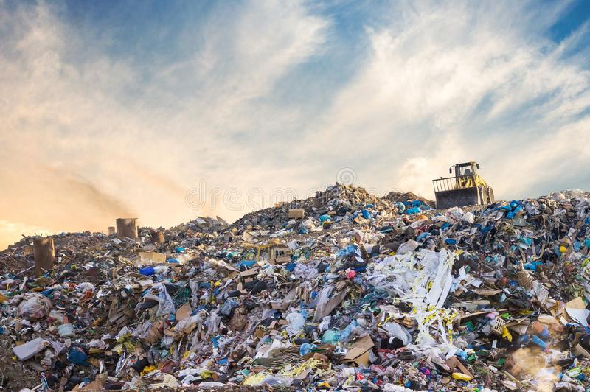

**Effects:**

Soil influences almost all aspects of our daily lives. Sometimes we fail to understand it. As a result of this, we sometimes fail to understand the effect that soil pollution has on our daily lives. Polluted soil means stunted crops or even a toxic underground water table. Some major effects of soil pollution are listed below.

-Effect on Health of Humans, Effect on Growth of Plants, Decreased Soil Fertility, Toxic Dust, Changes in Soil Structure, Poisoning of the Underground Water Table, etc.

**Solutions:**

Soil pollution is a complex problem that ought to be solved. It is essential that we all realize how important soil is to us. The earlier we realize this, the better we will be able to solve the problem of soil pollution. It is a complex problem, and thus, it requires everyone, from an individual to the government, to work in complete unison. Listed below are a few things that could help in reducing soil pollution.

-Reduced Use of Chemical Fertilizers, Reforestation and Afforestation Should be Promoted, Recycle and Reuse Products, Get the Locals Involved, Promote Use of Natural Manure, etc.

**Light Pollution**:

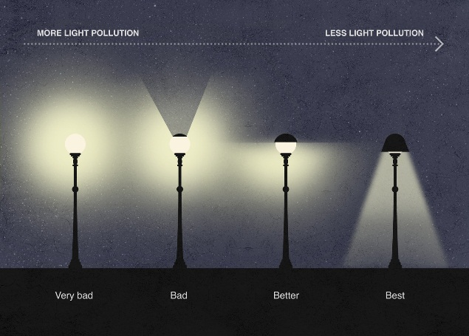This refers to the excessive or misdirected artificial light that can disrupt ecosystems, interfere with wildlife behavior, and contribute to energy waste. Light pollution, or artificial light at night, is the excessive or poor use of artificial outdoor light, and it disrupts the natural patterns of wildlife, contributes to the increase in carbon dioxide (CO2) in the atmosphere, disrupts human sleep, and obscures the stars in the night sky

**Causes: -**

Light pollution is unique as it is caused by man only. There is no comparable natural form of pollution like there is with carbon dioxide. The main causes of light pollution are: Poor Planning, Irresponsible Use, Overpopulation, Excessive Use of Light, Smog and Clouds, Lights from Cars and Other Motor Vehicles, Streetlamps, Light from Houses and Garage Lamps, Nighttime-lighting, Downtown Areas.

**Effects: -**

While many people choose to dismiss light pollution as being the price of modern life, it has serious effects on everything around it. The Earth’s ecosystem is dependent on cycles of natural light. Since these ecosystems are usually quite sensitive to changes in their environment, they may not be able to adapt to new artificial conditions developed from human-made light pollution. Sky glow alone can cause a loss in growth protection as the reflected light off the atmosphere will prevent the natural UV rays from reaching the Earth. This disrupts growth and decay cycles that our food, air and water supply is dependent on. There are also other effects of light pollution such as: Effects on People, Effects on Animals, Sleeping Problems, and Effects on Traffic, Air Pollution, and Waste of Resources.

**Solutions: -**

There are two basic approaches to solving light pollution – planning and education. Planning means more consideration of how areas are zoned and where lights are placed. It also means changing the types of lights used within the home, signs and streetlamps to more efficient bulbs and with a light out Use Certified Lighting put that is not so disruptive. The effective measures are: Light Shields, Warm Lighting, Motion Sensors, Cut off Light, Educate Others.

**Introduction of Project Report**

**Conservation of Natural Resources**

Conservation of natural resources is the protection and sustainable use of natural resources such as water, air, soil, minerals, forests, wildlife, marine resources, biodiversity, and renewable energy resources. The conservation of natural resources is essential for sustainable development, the well-being of current and future generations, and the protection of the environment. In this document, we will explore the importance of conservation of natural resources, the challenges faced in conserving natural resources, and the strategies and approaches used to conserve natural resources.

Importance of Conservation of Natural Resources:

Natural resources provide essential services such as food, water, air, shelter, and energy. They also support economic development, provide livelihoods, and contribute to cultural and spiritual values. However, the increasing demand for natural resources, population growth, climate change, and environmental degradation have led to the depletion of natural resources and the loss of their services.

Some common strategies used in solid waste management projects include:

1. Use less water. Taking shorter showers or turning off the faucet while brushing your teeth can reduce water waste in your home.
2. Turn off the lights. Turn off any lights or televisions after you leave a room. Unplug appliances like portable air conditioners, toasters, and coffeemakers when not in use, as they can continue to use small amounts of electricity.
3. Use renewable energy. Although renewable energy consumption has been in practice for centuries, recent years of climate change and global warming have pushed many scientists and researchers to look for ways to incorporate more green practices into our everyday lives.
4. Recycle. Making new products requires the use of resources, but recycling helps reuse the materials we already have.

**Objective of Subject**

**Aim: Study of Conservation of Natural Resources A**

**Objectives:**

1. To Maintaining Biodiversity
2. To Ensuring Resource Availability for Future Generation
3. To raise public awareness and promote community participation
4. To promote recycling and composting.

**Actual Methodology**

**Conservation of Natural Resources**

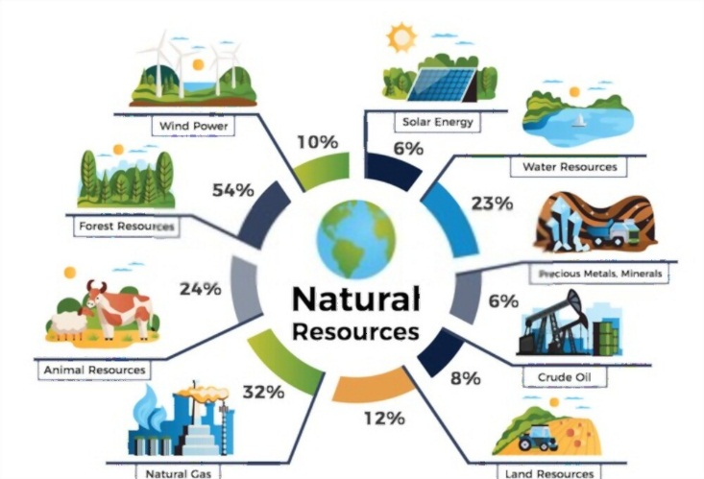 Conservation of natural resources is the protection, preservation, and sustainable use of natural resources to ensure their availability for future generations. It involves managing and using resources in a responsible manner to prevent depletion and damage to the environment. Natural resources include land, water, air, forests, minerals, and wildlife. In this 10-page information, we will explore the importance of natural resource conservation, the threats facing natural resources, and strategies for conservation.

**Importance of conservation of natural resources:**

Conservation of natural resources is crucial for several reasons, including:

1. Environmental protection: Natural resources play a vital role in maintaining the balance of the ecosystem. They support the growth of plants and animals, regulate climate, purify water and air, and provide habitats for wildlife. Conservation of natural resources helps protect the environment and prevent the loss of biodiversity.
2. Economic benefits: Natural resources are the basis of many economic activities, such as agriculture, forestry, mining, and tourism. Conservation of these resources helps to sustain these activities and supports the livelihoods of millions of people worldwide.
3. Climate change mitigation: Natural resources such as forests and oceans absorb carbon dioxide, a greenhouse gas that contributes to global warming. Conserving these resources helps to mitigate climate change and reduce the impacts of extreme weather events.

**Threats facing natural resources:**

Despite their importance, natural resources face several threats, including:

1. Overexploitation: Many natural resources are being overexploited, leading to depletion and degradation. For instance, overfishing has led to the collapse of several fish stocks, while deforestation has led to soil erosion, loss of habitat, and climate change.
2. Pollution: Pollution of air, water, and soil is a significant threat to natural resources. It affects the health of plants, animals, and humans and can cause irreversible damage to ecosystems.
3. Climate change: Climate change is altering the distribution and abundance of natural resources, leading to changes in ecosystems and the loss of biodiversity. It is also increasing the frequency and severity of extreme weather events, such as floods, droughts, and wildfires.

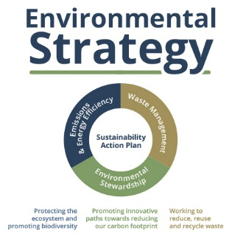**Strategies for conservation of natural resources:**

To conserve natural resources, we need to adopt strategies that promote sustainable use and protect the environment. Some of the strategies include:

1. Sustainable use: We need to use natural resources in a sustainable manner, ensuring that they are not depleted or damaged. This involves using resources efficiently, reducing waste, and promoting recycling.
2. Conservation measures: Conservation measures such as protected areas, wildlife corridors, and habitat restoration can help protect natural resources and preserve biodiversity.
3. Pollution control: Pollution control measures such as reducing emissions from industries and vehicles, promoting clean energy, and proper waste management can help prevent pollution and protect natural resources.
4. Climate change mitigation: Climate change mitigation measures such as reducing greenhouse gas emissions, promoting renewable energy, and forest conservation can help reduce the impacts of climate change on natural resources.
5. Education and awareness: Education and awareness programs can help people understand the importance of natural resource conservation and encourage them to adopt sustainable practices.
6. Renewable Energy: Renewable energy sources such as solar, wind, and hydro can reduce our dependence on fossil fuels, which are non-renewable and contribute to climate change. Using renewable energy sources can help to conserve natural resources such as coal and oil, reduce greenhouse gas emissions, and promote sustainable development.
7. Green Buildings: Green buildings are designed to be energy-efficient, environmentally sustainable, and resource-efficient. Green building practices can help conserve natural resources such as water, reduce energy consumption, and reduce greenhouse gas emissions.
8. Biodiversity Hotspots: Biodiversity hotspots are areas that are rich in biodiversity but are also threatened by human activities such as deforestation and habitat destruction. Protecting biodiversity hotspots can help conserve natural resources and preserve unique ecosystems.
9. Water Conservation: Water is a precious resource, and conserving it is essential for sustainable development. Water conservation strategies such as rainwater harvesting, water-efficient irrigation systems, and water reuse can help conserve natural resources and ensure their availability for future generations.
10. Sustainable Agriculture: Sustainable agriculture involves using farming practices that are environmentally sustainable, socially responsible, and economically viable. Sustainable agriculture practices can help conserve natural resources such as soil and water, reduce greenhouse gas emissions, and promote biodiversity.
11. Green Transportation: Green transportation refers to modes of transportation that are environmentally sustainable, such as electric vehicles, public transportation, and cycling. Using green transportation can help conserve natural resources such as oil and reduce greenhouse gas emissions.

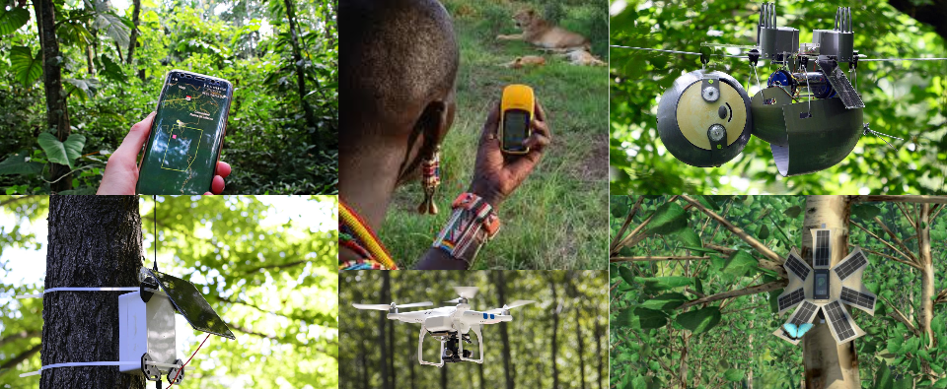**Importance of technology in conservation efforts.**

Technology has played a significant role in conservation efforts in recent years. Advancements in technology have enabled us to monitor natural resources more accurately, detect changes in ecosystems, and develop more effective conservation strategies.

Technology plays an important role in conservation efforts. Advancements in satellite technology, GPS tracking, drones, conservation apps, and AI are enabling us to monitor natural resources more accurately, detect changes in ecosystems, and develop more effective conservation strategies. By leveraging technology, we can conserve natural resources and protect them for future generations.

Technology has the potential to revolutionize conservation efforts and enable us to protect natural resources more effectively. By continuing to develop and deploy new technologies, we can ensure that future generations inherit a planet that is healthy, vibrant, and sustainable.

**Examples:**

1. Satellite Technology: Satellites provide high-resolution images that allow us to monitor changes in land use, vegetation cover, and deforestation. This information is essential for identifying areas that require conservation efforts and for tracking changes in biodiversity over time.
2. GPS Tracking: GPS tracking has revolutionized the way we monitor wildlife. Researchers can track the movements of animals and gain insights into their behaviour and habitat use. This information is crucial for developing conservation strategies that protect endangered species and their habitats.
3. Drones: Drones have become increasingly popular for monitoring wildlife and habitat changes. They can provide high-resolution images and videos of inaccessible areas, allowing researchers to identify changes in ecosystems that would have been difficult to detect otherwise.
4. Conservation Apps: There are several conservation apps available that allow people to contribute to conservation efforts. These apps can be used to report sightings of endangered species, monitor water quality, and participate in citizen science projects.
5. Artificial Intelligence: AI technology is being used in conservation efforts to analyse large datasets and identify patterns that would be difficult for humans to detect. For example, AI can be used to analyse satellite images and identify areas that require conservation efforts.
6. Blockchain: Blockchain technology is being used to track the trade of endangered species and prevent illegal wildlife trafficking. By creating a secure and transparent ledger of transactions, blockchain can help ensure that wildlife products are sustainably sourced and legal.
7. In Vitro Meat: In vitro meat is a type of meat that is produced by growing animal cells in a lab. It has the potential to reduce the demand for meat from livestock, which can help to conserve natural resources such as water, land, and energy.
8. Robotics: Robotics technology is being used to study and monitor marine environments, where it can be difficult for humans to operate. For example, underwater robots can be used to study deep-sea habitats and monitor the health of coral reefs.
9. Environmental Sensors: Environmental sensors are being used to monitor air and water quality, soil health, and climate change. They can provide real-time data on environmental conditions, which is essential for developing effective conservation strategies.
10. Wildlife Monitoring Systems: Advanced wildlife monitoring systems use cameras, sensors, and other technologies to detect and track the movements of poachers and illegal wildlife traders. This technology can be used to identify poaching hotspots, track wildlife populations, and monitor the movements of illegal traders.
11. Anti-Poaching Drones: Drones equipped with thermal cameras and other sensors can be used to monitor wildlife reserves and detect poachers. They can also be used to identify and track poachers' vehicles and other equipment, making it easier to catch and prosecute offenders.
12. DNA Testing: DNA testing is being used to identify the origins of illegal wildlife products, such as ivory and rhino horn. By tracing the DNA back to its source, authorities can identify the poaching hotspots and target their efforts to protect these areas.
13. Social Media Monitoring: Social media is increasingly being used as a platform for the illegal trade of wildlife products. Conservationists are using social media monitoring tools to identify and track illegal traders, and to raise awareness about the consequences of wildlife trafficking.
14. Wildlife Forensics: Wildlife forensics is the application of scientific techniques to investigate crimes against wildlife. This includes the use of DNA testing, microscopy, and other analytical techniques to identify illegal wildlife products and track their origins.

**Conservation of Natural Resources Location World Wide: -**

There are many places in the world that are known for their efforts to conserve natural resources. Here are some examples:

1. Serengeti National Park, Tanzania: Serengeti National Park is home to one of the largest mammal migrations in the world and is known for its diverse ecosystem. Efforts are being made to conserve the park's biodiversity through initiatives such as anti-poaching patrols and community-based conservation projects.
2. Yellowstone National Park, USA: Yellowstone National Park is a UNESCO World Heritage Site and is home to several endangered species such as the grey wolf and the grizzly bear. Conservation efforts in the park include the reintroduction of native species and the implementation of sustainable tourism practices.
3. The Great Barrier Reef, Australia: The Great Barrier Reef is the largest coral reef system in the world and is home to several endangered species of marine life. Conservation efforts in the region include initiatives such as coral planting and marine protected areas.
4. Bwindi Impenetrable Forest, Uganda: Bwindi Impenetrable Forest is home to nearly half of the world's remaining mountain gorillas. Conservation efforts in the region include the establishment of national parks and community-based conservation projects.
5. Costa Rica's Osa Peninsula: The Osa Peninsula is home to several endangered species such as the jaguar and the scarlet macaw. Conservation efforts in the region include the establishment of national parks and community-based conservation projects.

These are just a few examples of the places in the world that are known for their efforts to conserve natural resources. Through initiatives such as national parks, marine protected areas, and community-based conservation projects, these locations are working to protect the natural world for future generations.

**Conservation of Natural Resource in India:** -

India is a country with a rich natural heritage, from the towering Himalayas to the vast forests of the Western Ghats, the country is home to a diverse range of flora and fauna. However, over the years, rapid industrialization and urbanization have taken a toll on the country's natural resources. To counter this, several efforts are underway to conserve India's natural resources.

Here are some of the key conservation initiatives in India:

1. Project Tiger: Project Tiger is a conservation initiative launched by the Indian government in 1973 to protect the Bengal tiger. The project has been successful in increasing the tiger population in India and has now expanded to include other endangered species. The project works towards habitat conservation, anti-poaching activities, and community participation in conservation efforts.
2. National Parks and Wildlife Sanctuaries: India has over 100 national parks and more than 500 wildlife sanctuaries. These protected areas are home to several endangered species and are crucial for the conservation of India's natural resources. The national parks and wildlife sanctuaries are managed by the government and are protected by law.
3. Project Elephant: Project Elephant is a conservation initiative launched by the Indian government in 1992 to protect the Asian elephant. The project works towards elephant conservation, habitat management, and reducing human-elephant conflict.
4. National River Conservation Plan: The National River Conservation Plan was launched in 1985 to improve the quality of India's rivers. The plan works towards controlling pollution, conserving river ecosystems, and creating awareness about river conservation.
5. Coastal Regulation Zone Notification: The Coastal Regulation Zone Notification was introduced in 1991 to regulate development activities in the coastal regions of India. The notification aims to conserve the coastal ecosystems and protect the livelihoods of coastal communities.
6. Green India Mission: The Green India Mission was launched in 2014 to increase India's forest cover and improve the quality of forest ecosystems. The mission aims to increase the forest cover by 5 million hectares and improve the quality of existing forests.
7. Swachh Bharat Abhiyan: The Swachh Bharat Abhiyan was launched in 2014 to promote cleanliness and sanitation in India. The campaign aims to reduce pollution and improve the quality of India's natural resources.
8. Energy Conservation: The government of India has launched several initiatives to promote energy conservation in the country. These initiatives aim to reduce energy consumption and promote the use of renewable energy sources.

**Location in India: -**

1. The Western Ghats: The Western Ghats are a mountain range that runs along the western coast of India. They are home to several endangered species of plants and animals, and efforts are being made to conserve the region's biodiversity through initiatives such as the Western Ghats Hornbill Foundation.
2. Sundarbans National Park: Sundarbans National Park is located in the delta region of the Ganges, Brahmaputra, and Meghna rivers in West Bengal. It is home to the Royal Bengal Tiger and several other endangered species. Conservation efforts in the region include initiatives such as the Sundarbans Biosphere Reserve.
3. Keoladeo National Park: Keoladeo National Park is located in Rajasthan and is a major bird sanctuary. It is home to several migratory bird species, and efforts are being made to conserve the wetland ecosystem of the park.
4. Kanha National Park: Kanha National Park is located in Madhya Pradesh and is one of the largest national parks in India. It is home to the Bengal Tiger and several other endangered species, and conservation efforts in the region include initiatives such as the Kanha Conservation Programme.
5. Silent Valley National Park: Silent Valley National Park is located in Kerala and is home to several endemic species of plants and animals. Conservation efforts in the region include initiatives such as the Silent Valley National Park Conservation Programme.

These are just a few examples of the locations in India where efforts are being made to conserve natural resources. Through initiatives such as national parks, biosphere reserves, and conservation programmes, India is working to preserve its rich natural heritage for future generations.

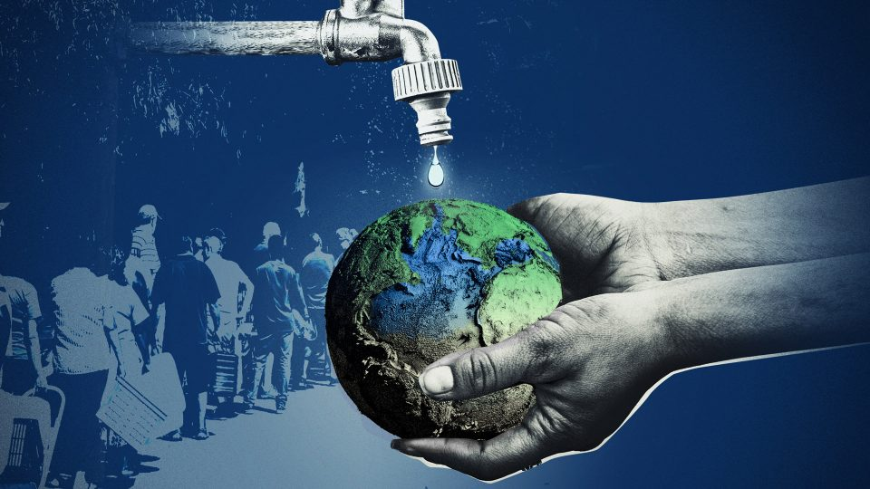**Conservation and Management of Water Resources (by name here): -**

Life on the earth cannot be sustained without water, whether of human beings, animals, flora, or fauna. The demand for fresh water is increasing every day, and the available source of good quality water is in the form of precipitation only, which is more or less constant. It is estimated that this available fresh water on earth is around 36,000 Km3 , which returns to the oceans as runoff. It is, vital to manage this water judiciously for the survival of life on this planet.

On the earth, about ninety-seven per cent of the total available water is saline and constitutes the oceans. The remaining three per cent is the fresh water, of which seventy-five per cent lies buried as the groundwater, and the remaining one per cent constitutes the fresh water available on the land surface in the form of rivers, lakes, reservoirs, soil moisture and some part of it in the atmosphere.

To effective use freshwater, projects on irrigation, water supply, flood control, water power, water harvesting and navigation are taken up, which require design of different type of energy dissipating, conveyance, and storage structures. Such design work requires hydrological investigations related to storage capacity of reservoirs, flood magnitude and its frequency of occurrence, runoff peak, and seasonal variations in stream discharge.

**Conservation of Soil (by name here): -**

Soil Erosion and Sedimentation: -

 Soil erosion is the physical removal of topsoil by different agents of nature, viz. falling raindrops, running water, wind velocity and gravitational pull. The Soil Conservation Society of America has defined it as the wearing away of the land surface by running water, wind, ice or other geological agents, including such processes as gravitational creep.

Conservation of Soil: -

The erosive power of natural agents and erodibility properties of the soil combine to cause erosion of soil. This process gets accelerated with and increase in the slope of the land surface and is retarded by a decrease in the slop. The erosive power of rain and wind of the land surface can be decreased by intercepting these agents with a vegetative cover, by increasing the roughness of the land surface by different tillage operations and by decreasing the slope of the land by adoption of suitable practice, viz. bunds, terraces and other such structures. These practices are broadly classified into vegetative, soil management, and mechanical practice, and are employed as per the availability of resource, locally available construction material and expertise, and the severity of soil erosion. The design of these measures for cultivated lands is different from that for forest lands.

**Soil Conservation Practices (by name here): -**

Mechanical and vegetative practice are employed on milder slopes for conservation of soil, by farming across the slope of the land. The basic principle underlying this approach is to cause reduction in the effect of slope on the runoff velocity and, thereby, reduce soil erosion. One steeper slopes, mechanical measures and structure are constructed to reduce the effect of slope on runoff velocity. The most common mechanical measure is the grading (levelling) of land surface, but on very steep slopes deeper cuts and fills are encountered which tend to expose the subsoil, and subsequently cause reduction sin the fertility level of soil. In such cases, the land is divided into strips and laid across the slope int he forms of terraces and bunds. Basically, except for bench terraces, in al these strips, the soil forms the top of the strip erodes and settles down at the bottom of the strip, and eventually levels up itself with a grade that is not very erosive.

The following types of vegetative and mechanical practice are being used to present:

* 1. Contouring
  2. Strip cropping
  3. Tillage operation

Author of these book explain how soil erosion take place in first place, how we can prevent soil erosion, and how to face soil erosion problems with solution with deep understanding.

**Benefits of Conservation of Natural Resources: -**

Conservation of natural resources has numerous benefits, not only for the environment but also for human well-being. Conservation of natural resources is essential for sustaining life on Earth. By protecting these resources, we can ensure the long-term health and well-being of both the environment and human society.

Here are some of the key benefits of conserving natural resources:

1. Biodiversity conservation: Natural resources such as forests, wetlands, and coral reefs are home to a vast array of plant and animal species. By conserving these ecosystems, we can protect the biodiversity of the planet.
2. Climate change mitigation: Natural resources such as forests and oceans play a critical role in regulating the earth's climate. By conserving these ecosystems, we can reduce the impact of climate change.
3. Economic benefits: Natural resources are a critical source of livelihood for millions of people around the world. By conserving these resources, we can ensure sustainable use of these resources, which can help to support local economies and provide long-term benefits.
4. Water conservation: Natural resources such as rivers, lakes, and wetlands are crucial for maintaining a steady supply of clean water. By conserving these ecosystems, we can ensure the availability of clean water for human consumption, agriculture, and other uses.
5. Soil conservation: Soil erosion is a significant threat to agricultural productivity and food security. By conserving natural resources such as forests and grasslands, we can prevent soil erosion and maintain soil fertility.
6. Recreational and cultural benefits: Natural resources such as parks, beaches, and cultural landscapes provide recreational opportunities and cultural significance. By conserving these resources, we can ensure that future generations can enjoy these benefits.
7. Improved air quality: Natural resources such as forests play a critical role in filtering the air we breathe. By conserving these ecosystems, we can improve air quality and promote human health.

**Role of Students in Conservation of Natural Resource**: -

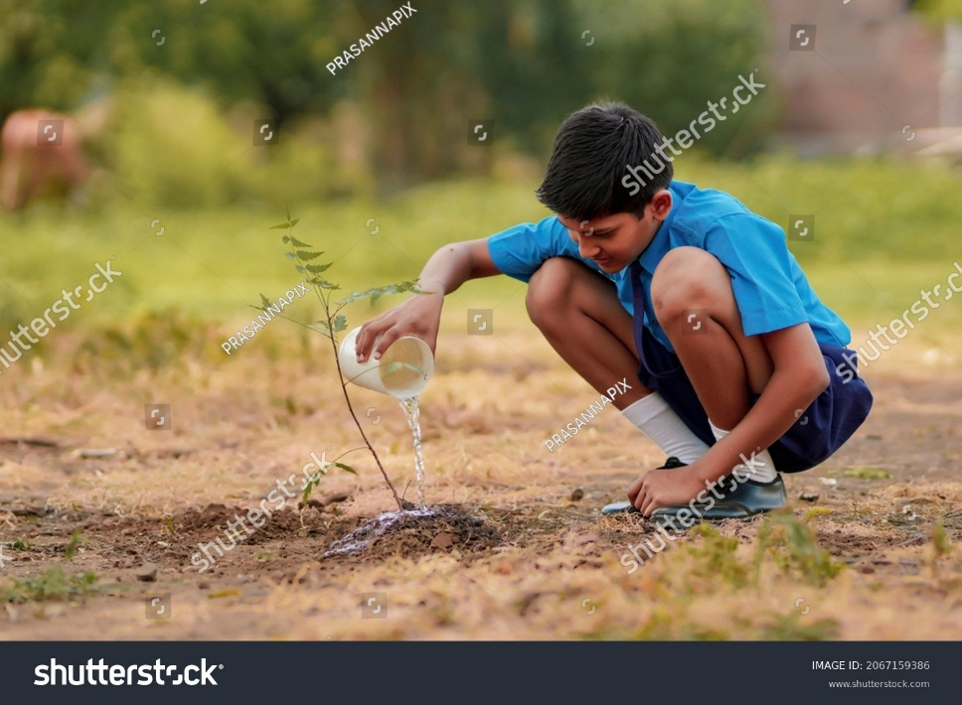

Students can make a significant contribution to conservation efforts by educating themselves, raising awareness, reducing their ecological footprint, volunteering, advocating for policy change, and practicing sustainable living. By doing so, they can help ensure a sustainable future for generations to come.

Students play a critical role in conservation of natural resources, as they are the future generation who will inherit the planet. Here are some of the ways in which students can contribute to conservation efforts:

1. Educating themselves: Students can start by educating themselves about the importance of natural resources and the threats they face. They can learn about the impacts of human activities such as pollution, deforestation, and climate change on the environment.
2. Spreading awareness: Students can use their voice to raise awareness about the need for conservation. They can organize events, campaigns, and social media drives to spread the word and encourage others to take action.
3. Reducing their ecological footprint: Students can make small changes in their daily lives to reduce their ecological footprint. For example, they can use eco-friendly products, reduce waste, and conserve water and electricity.
4. Volunteering for conservation organizations: Students can volunteer their time and skills for conservation organizations working to protect natural resources. They can assist in habitat restoration, wildlife conservation, and other initiatives.
5. Advocating for policy change: Students can advocate for policy change by writing to their representatives and attending public meetings. They can push for policies that promote conservation and reduce environmental harm.
6. Learning and practicing sustainable living: Students can learn and practice sustainable living by using renewable energy sources, growing their own food, and conserving natural resources.

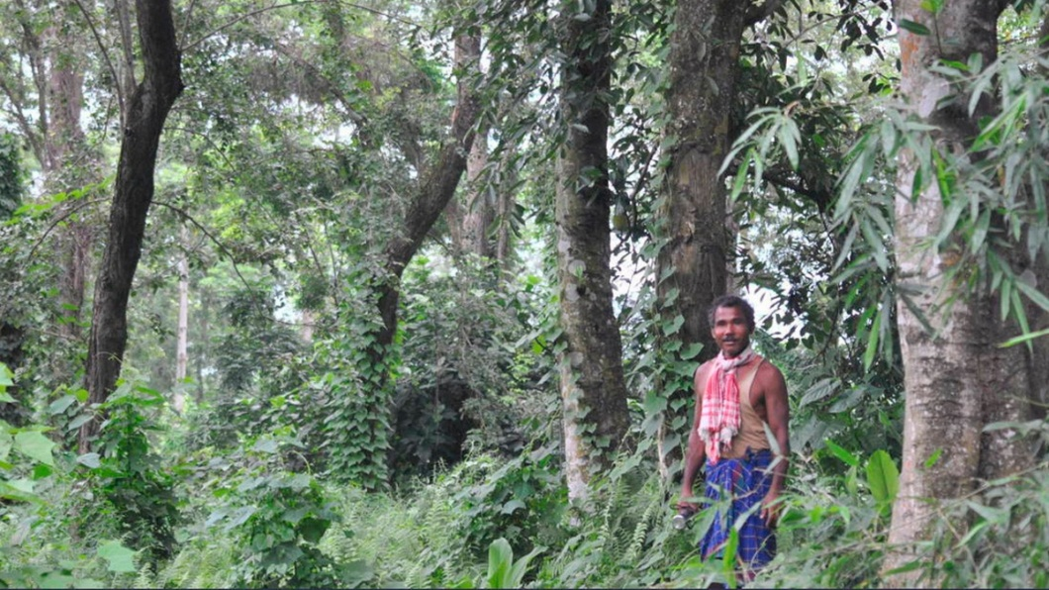**“Forest Man of India”: -**

Jadav Payeng, also known as the "Forest Man of India," is an environmental activist and conservationist from the northeastern state of Assam in India. Payeng is known for his incredible efforts in planting trees and creating a forest on a barren sandbar on the Brahmaputra River in Assam, which is now home to a diverse range of wildlife. Payeng was born in 1963 in the Jorhat district of Assam. He grew up in a small village near the Brahmaputra River and spent most of his childhood in close contact with nature. As a young boy, Payeng was disturbed by the alarming rate of erosion on the river's sandbars, which were turning into barren wastelands devoid of any vegetation.

In 1979, when Payeng was just 16 years old, a severe flood hit the region, washing ashore many snakes who died due to the lack of tree cover. This incident left a deep impression on Payeng, who resolved to do something to help the area's ecosystem. He began planting saplings on the barren sandbar, which had no trees or vegetation at that time, and continued to do so for several years. Payeng's efforts did not go unnoticed, and soon people started taking notice of the growing forest on the sandbar. However, it wasn't until the year 2000 that Payeng's work gained national attention when a journalist stumbled upon the forest while on assignment and reported on his story.

Payeng's forest, which is now known as Molai Forest, covers an area of over 1,360 acres and is home to a diverse range of wildlife, including tigers, rhinos, deer, and elephants. He has received numerous awards and recognition for his work, including the Padma Shri, one of India's highest civilian awards, in 2015. Payeng's story is a shining example of the power of individual action and the importance of conservation efforts to protect our planet's natural resources. He continues to inspire many people around the world to take action and work towards environmental conservation.

**Observations**

Conservation of natural resources has been observed to have several positive impacts, including:

1. Preservation of Ecosystems: Conservation efforts have led to the preservation of important ecosystems such as rainforests, wetlands, and coral reefs. These ecosystems are home to numerous species of plants and animals and play a vital role in maintaining the balance of the Earth's ecosystem.
2. Protection of Endangered Species: Conservation efforts have helped protect endangered species such as tigers, pandas, elephants, and whales. These efforts have led to an increase in their populations and helped to prevent their extinction.
3. Sustainable Use of Resources: Conservation efforts have promoted the sustainable use of natural resources such as water, air, soil, and energy. This has helped to reduce the depletion of these resources and ensured their availability for future generations.
4. Reduction of Pollution: Conservation efforts have helped to reduce pollution and its harmful effects on the environment and human health. By reducing waste and promoting sustainable practices, conservation efforts have led to cleaner air, water, and soil.

However, challenges remain in the conservation of natural resources. These challenges include the increasing human population and demand for resources, climate change, and habitat loss. Therefore, it is crucial to continue conservation efforts and promote sustainable development practices to ensure the long-term sustainability of our planet.

**Summary and Conclusion**

**Summary:**

The conservation of natural resources is a vital concept that emphasizes the need to manage and utilize natural resources sustainably. It involves preserving resources for future generations and preventing depletion due to human activities. Conservation efforts include reducing waste and pollution, reforestation, energy conservation, and sustainable farming practices.

The increasing human population and demand for resources pose a significant challenge to conservation efforts. Sustainable development practices are necessary to balance economic growth with environmental protection. Overall, conservation of natural resources is essential to maintain ecological balance and biodiversity and ensure the long-term sustainability of our planet.

The conservation of natural resources faces various challenges, including the lack of political will, funding, awareness, and education, and conflicts over natural resources. To address these challenges, there is a need for increased political will, funding, and awareness on the importance of natural resource conservation.

**Conclusion:**

The conservation of natural resources is essential for sustainable development and the well-being of future generations. Various approaches can be used to conserve natural resources, including sustainable development, integrated natural resource management, environmental education and awareness, legal and policy frameworks, and community-based natural resource management.

The conservation of natural resources is essential for sustainable development, and it is everyone's responsibility to contribute to this effort. By adopting sustainable practices, protecting natural habitats, and promoting conservation initiatives, we can ensure the well-being of current and future generations and protect the environment. It is our duty to conserve natural resources and leave a sustainable world for future generations.

**Bibliography**

1. "Conservation of Natural Resources." National Geographic Society, www.nationalgeographic.org/encyclopedia/conservation-natural-resources/.
2. "Conservation of Natural Resources." Environmental Science, www.environmentalscience.org/conservation-natural-resources.
3. "What is Conservation of Natural Resources?" Conserve Energy Future, [www.conserve-energy-future.com/conservation-of-natural-resources.php](http://www.conserve-energy-future.com/conservation-of-natural-resources.php).
4. https://www.nationalgeographic.org/society/

**Project Format (Don’t print it) this is for your kind information**

1. **Title(Cover Page)** (1 page)
2. **Certificate** (1 page)
3. **Declaration** (1 page)
4. **Index** (1 page)

|  |  |  |
| --- | --- | --- |
| Sr.No. | Contents | Page.N  o. |
| 01 | ------- | 01 to -- |

1. **Introduction of Environment, Its importance, various types of Environmental Pollution.** (3 page)
2. **Introduction of Project Report (Vishay Nivad/Prastavana)** (1 page)
3. **Objective of Subject (Uddishte)** (1 page)
4. **Actual Methodology ( Pratyaksha karyapadhati)** (10-15 pages)
5. **Observations (Nirikshane)** (1 -2 pages)
6. **Summary and Conclusion (Nishakarsh) (2+1 Pages)**
7. **Bibliography : Review of related Literature (samdhit sahityacha sandrbha)**

**Generally use A4 size bond paper for print**

**Use 12 size font in Times New Roman .**

**Keep Headline 12 font with Bold**

**Show your soft copy before print**

**Check the spelling before print**